**UART Driver before warning check:**

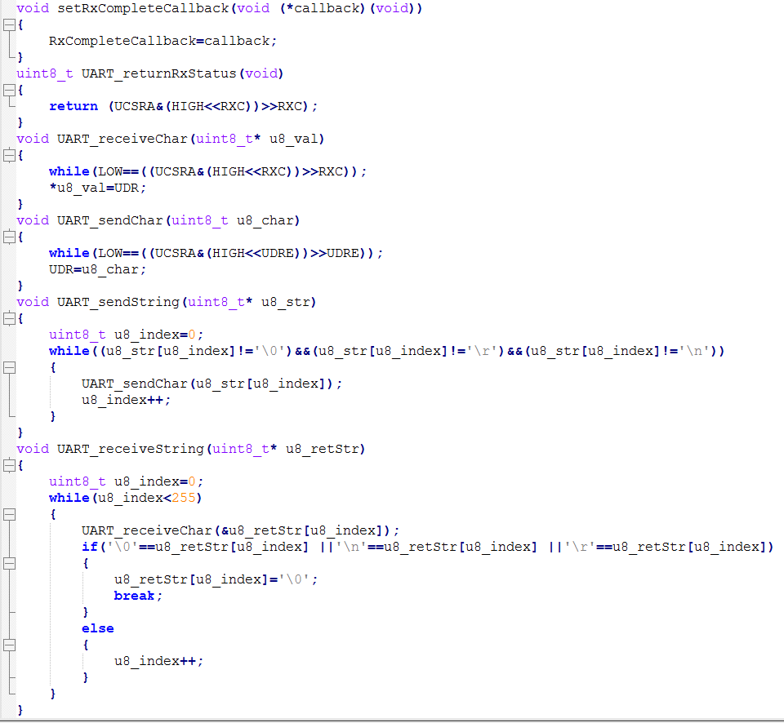

**Warnings and possible safety hazards:**

* No pointer checks
* Pointers don’t get passed to functions as void
* Lvalue in condition checking must be a constant

**UART Driver after changes:**

**The changes made:**

* Checking if pointer has NULL value
* Passing pointer to function as void and casting it inside
* Lvalue in conditions is a predefined constant value
* Returning errors depending on pointer validity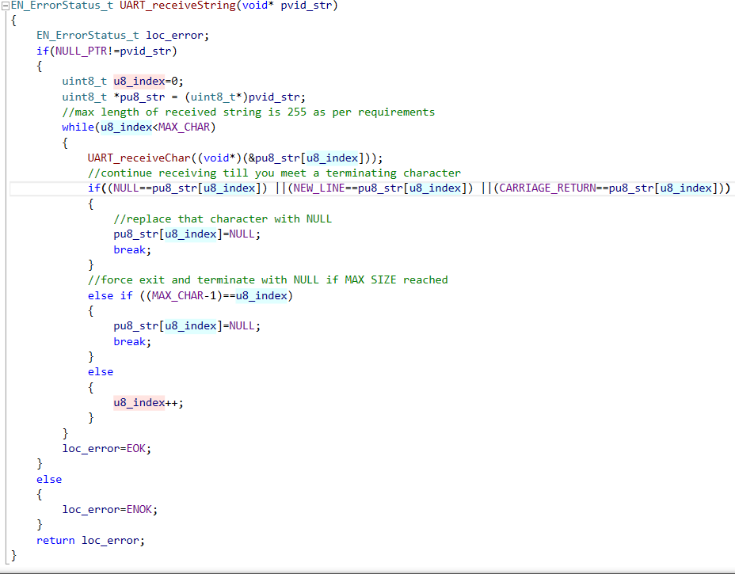 at the single point of exit
* Each If must have an else.

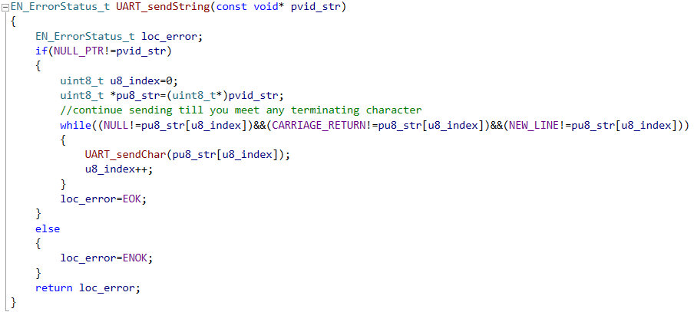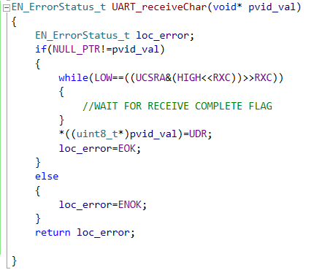

New UART github Link:

<https://github.com/yahiaElGamal98/SAFE_UART.git>

Old UART github Link:

https://github.com/yahiaElGamal98/OLD_UART.git